**RELAY CONTROLLING AN EXTERNAL SYSTEM**

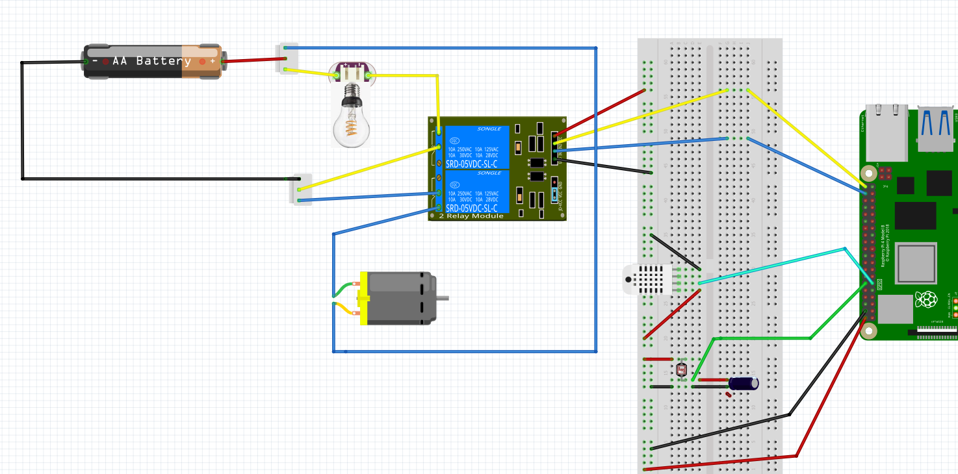

**D**

**V**

**G**

**THIS CIRCUIT USES NORMALLY OPEN**

**PIN 18**

**PIN 17**

**PIN 21**

**LIGHTS**

**PIN 20**

**MOTOR**

**IN2**

**IN1**

**IN1**

**IN2**